Japan Educational International Model United Nations |  | A/79/DR.xx
 | United Nations  General Assembly | Distr.:Limited
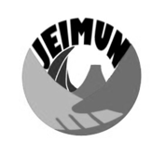 |  | 7 January, 2024
 |  | Original: English
United Nations General Assembly, Seventy-ninth Plenary Session
Agenda item: United Nations Security Council Reform
Sponsors: (List all sponsoring countries in alphabetical order)

The General Assembly,
Preamble Clauses start here:

- Operative Clauses start here:

